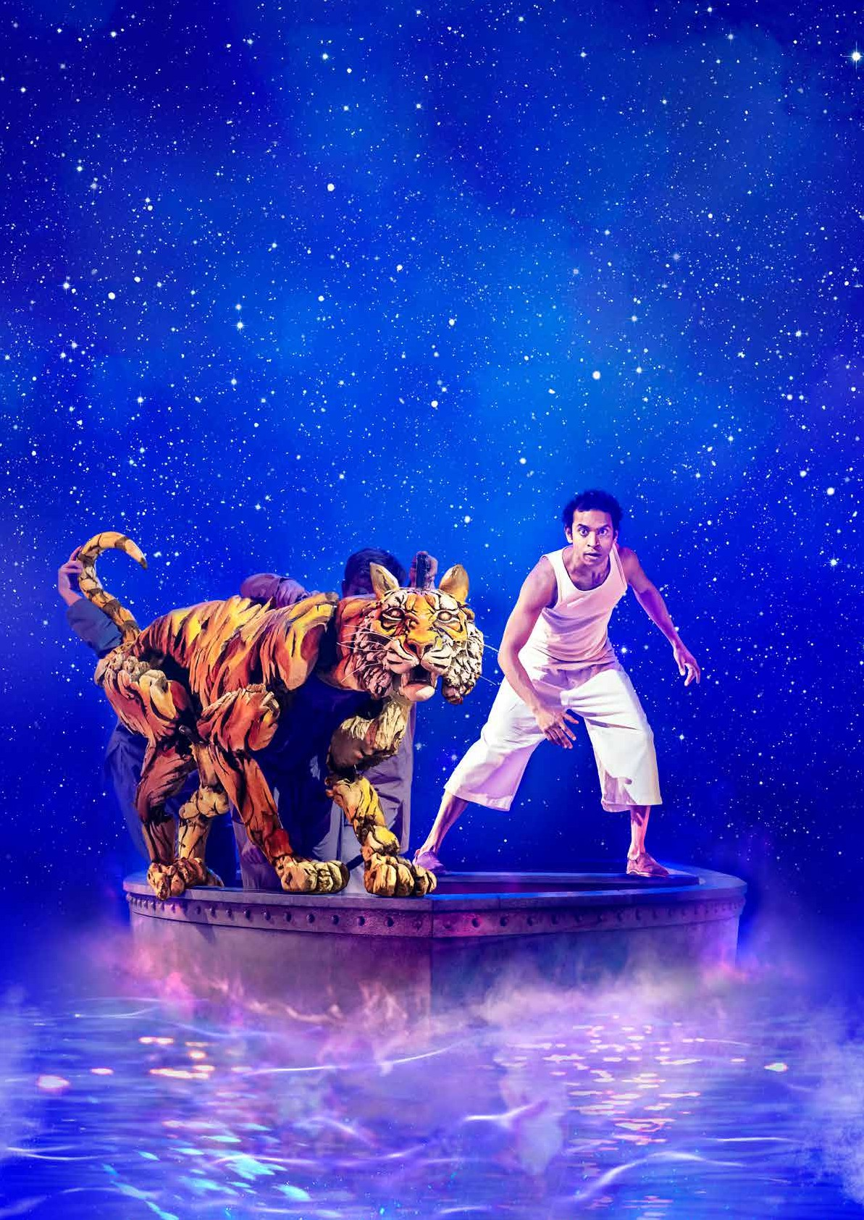

Homework

# Activities

Themes for Discussion

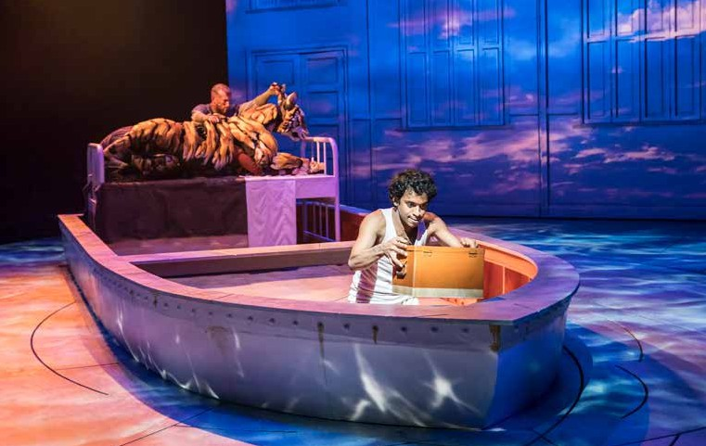

#### TRANSLATE THE TEXT Resilience

Photo by Johan Persson

Pi spends eight months at sea and is determined to survive. He is also determined to challenge the preconceptions and assumptions made by Mr Okamoto in the hospital room in Mexico.

Mamaji prays that “may these challenging times make us stronger”. As he starts to experience visions, Pi sees Mrs Biology Kumar who tells him, “Use logic and maths, Pi, use everything you have and defy the odds”. Although he is no longer surrounded by his family, Pi uses what they have taught him in his bid to survive.

Mr Okamoto closes the play with the words, “This is an astounding story of courage and endurance in the face of unimaginable difficulty…”

#### Family

In order for us to understand the weight of Pi’s grief, we need to see the family interact before the Tsimtsum sinks. Amma is very strongly associated with home, as Pi’s father tells him “Amma is making home away from home” when they board the Tsimtsum, and she also brings a Tiffin tin of food to help sustain them. Pi has a typically fractious relationship with his sister but the love and loyalty between them is very clear.

#### Grief

When we first meet Pi in the hospital room, he is clearly deeply traumatised by the loss of his family. It is difficult to reconcile Mr Okamoto’s constant questioning with Pi’s need to recover from the trauma he has experienced. We might also consider the pairings between the animals and the humans in the story One interpretation is that Pi uses the animals in order to process what has happened – as a method of understanding the extreme circumstances in which he and his family found themselves.

#### The human survival instinct

Father tells Pi, “Don’t think any animal is harmless. Life will defend itself no matter how small it is. This world is dangerous. It’s a mistake to be complacent.” Mamaji is teaching Pi to swim, and this becomes a metaphor for his ability to survive. Shortly before they leave for Canada, Mamaji tells Pi, “not too much thinking, just keep moving forward” and that Pi must “conquer open water”. We might assume that this is foreshadows Pi’s need to cling to life, and deal with the trauma and loss that he endures along the way.

#### Reality vs. fantasy

Towards the end of the play, Mr Okamoto expresses disbelief at Pi’s ability to survive in a lifeboat with a tiger. Pi tells him, “Life is hard to believe. God is hard to believe…I applied reason and logic at every moment. But be excessively reasonable and you risk throwing out the universe with the bath water.” Here the two characters are struggling to understand each other’s perspectives. It is up to the audience to consider what they believe in, and what they believe truly happened during Pi’s time at sea. Yann Martel and Lolita Chakrabati both wish us to consider our relationship with truth and with fantasy. When Mr Okamoto tells Pi, “A story has an element of invention. We don’t want invention. We want facts” Pi responds, “You want a story that confirms what you already know. You want dry, yeast-less factuality. A story without animals.”

#### Individuality

Pi is only 17 years old, and yet is self-assured when he interacts with Mr Okamoto. Pi tells him, “We’re all children, Mr Okamoto”. When Mr Okamoto becomes frustrated that Pi will not, or cannot, provide the information he requires, Pi retorts, “If these are not the answers you want Mr Okamoto, then you must ask different questions”. Pi is keen to assert his own beliefs, despite his vulnerability and trauma.

#### Morality

There are two parallel stories in Life of Pi, one with animals, and one without. Although Yann Martel and Lolita Chakrabati are keen for the audience to create their own interpretations, the concept of who gets to take the life of another being (animal or otherwise) is key to the story. One interpretation is that Richard Parker is a parallel character to Pi, who must take drastic action to survive and to avenge the murder of his loved ones (Orangutan representing his mother, for example).

#### Civilisation

When he is forced to eat the turtle, Pi is conflicted. Commander Grant Jones tells him, “Never forget above all you are a gentleman. Civilisation is the only thing that separates man from beast. Remember the definition of a gentleman is he who uses a butter knife even when dining alone.”

Throughout the story, Pi is forced to make decisions that would be considered uncivilised, or even morally wrong, and one interpretation of the story is that Pi must invent the animals to distance himself from those actions that he finds abhorrent, despite the fact that he had no option if he were to survive.

#### Faith & Religion

Religion is mentioned very early on in the play. Pi challenges Mr Okamoto by saying, “I will tell you everything…because my story will make you believe in God”. He mentions later, “Many of us lose God along life’s way”

Mr Okamoto and Pi have a number of exchanges about religion. Mr Okamoto tells Pi, “I didn’t lose God. I have never been a believer. Religion is a habit rather than a truth. A crutch in time of need.” Pi also exchanges views with several religious leaders when they meet in Pondicherry Market and compete for Pi’s loyalty. He eventually tells them, “You’re just asking me to choose the better story”.

Pi also tells Mr Okamoto, “choosing doubt as a philosophy of life is like choosing immobility as a mode of transport”.

#### Migration

Pi and his family board the Tsimtsum in order to travel to Canada. They are leaving India because of the political tensions which make it dangerous and unpredictable to live there any longer.

#### Writing task:

Choose an animal and describe it. This could be a domestic animal, or it could be an exotic or rare animal. You may need to do some research in order to be as accurate as possible. Remember that Yann Martel did a huge amount of zoological research for the novel.